EMBEDDED SYSTEMS INTERNSHIP REPORT
SMART TEMPERATURE CONTROL SYSTEM USING ARDUINO UNO AND TMP36 SENSOR
Submitted By: Yavvari Laxman Rao
College: Rajiv Gandhi University of Knowledge Technologies (RGUKT), Ongole

- INTRODUCTION
A Smart Temperature Control System is an embedded system project used to monitor ambient temperature and automatically perform an action based on predefined conditions. The system uses a TMP36 temperature sensor to measure temperature and an Arduino UNO to process the sensor data. When the temperature exceeds a specified threshold value, the Arduino automatically turns ON an LED, acting as an alert indicator. The temperature readings are continuously displayed on the Serial Monitor.

- COMPONENTS USED
S.No | Component | Purpose
1 | Arduino UNO | Main Controller
2 | TMP36 Temperature Sensor | Measures Temperature
3 | LED | Temperature Alert Indicator
4 | 220Ω Resistor | Limits LED Current
5 | Jumper Wires | Circuit Connections
6 | USB Power Supply | Provides Power

- CIRCUIT DIAGRAM

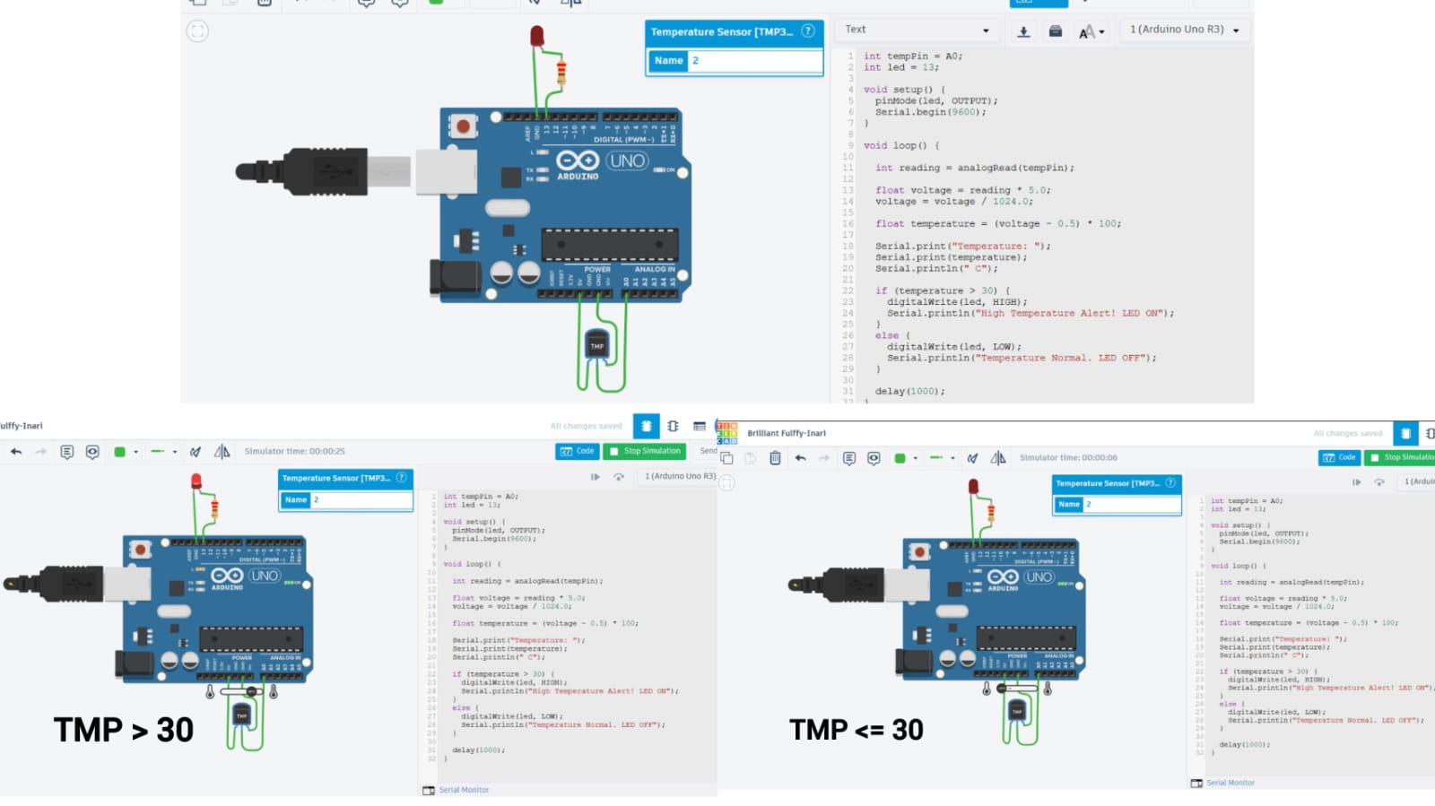
Connections:
• TMP36 Left Pin → 5V
• TMP36 Middle Pin → A0
• TMP36 Right Pin → GND
• Arduino Pin 13 → 220Ω Resistor → LED Anode (+)
• LED Cathode (-) → GND

- ARDUINO PROGRAM

int tempPin = A0;
int led = 13;
void setup() {
pinMode(led, OUTPUT);
Serial.begin(9600);
}
void loop() {
int reading = analogRead(tempPin);
float voltage = reading * 5.0;
voltage = voltage / 1024.0;
float temperature = (voltage - 0.5) * 100;
Serial.print("Temperature: ");
Serial.print(temperature);
Serial.println(" C");
if (temperature > 30) {
digitalWrite(led, HIGH);
Serial.println("High Temperature Alert! LED ON");
}
else {
digitalWrite(led, LOW);
Serial.println("Temperature Normal. LED OFF");
}
delay(1000);
}
- WORKING PRINCIPLE
The TMP36 sensor continuously measures the surrounding temperature and produces an analog voltage proportional to the temperature. Arduino UNO reads this voltage through analog pin A0 and converts it into temperature values in degrees Celsius. The measured temperature is displayed on the Serial Monitor. If the temperature rises above 30°C, the Arduino automatically turns ON the LED to indicate a high-temperature condition. When the temperature falls below the threshold value, the LED turns OFF. This demonstrates embedded automation using decision-making logic.
- APPLICATIONS
• Smart Temperature Monitoring Systems
• Industrial Temperature Control
• Environmental Monitoring
• Smart Home Automation
• Server Room Temperature Monitoring
• IoT-Based Monitoring System.
- CONCLUSION
The Smart Temperature Control System using Arduino UNO and TMP36 sensor was successfully designed and simulated in Tinkercad. The system continuously monitors temperature and automatically activates an LED when the temperature exceeds the preset threshold. This project demonstrates sensor interfacing, automation logic, real-time monitoring, and embedded system design using Arduino.

